

PROJECT REPORT

Digital Photo Printing

GROUP MEMBERS

1. Mohsin Abbasi
2. Charles Stephen

CONTENTS

……..……………….…………Introduction………………………………..

1. Definition of the Problem……………………………………..
2. Requirement Analysis…………………………………………..
3. Design Phase……………………………………………………….
4. Source Code……………………………………………………….
5. User Guide…………………………………………………………

Introduction

The  thirst  for  learning,  upgrading  technical  skills  and  applying  the  concepts  in  real life environment at a fast pace is what the industry demands from IT professionals today.  However  busy  work  schedules,  far-flung  locations,  and  unavailability  of convenient time-slots pose as major barriers when it comes to applying the concepts into  realism. And  hence  the  need  to  look  out  for  alternative  means  of implementation in the form of laddered approach.

The above truly pose as constraints especially for our students too! With their busy schedules,  it  is  indeed  difficult  for  our  students  to  keep  up  with  the  genuine  and constant need for integrated application which can be seen live especially so in the field of  IT  education  where technology  can  change on  the spur of  a moment.  *Well, technology does come to our rescue at such times!!*

Keeping  the  above  in  mind  and  in  tune  with  our  constant endeavour  to  use Technology in our training model, we at Aptech have thought of revolutionizing the way  our  students  learn  and  implement  the  concepts  using  tools  themselves  by providing a *live and synchronous eProject   learning environment!*

1. Definition of the Problem

The problem statement is attached separately in a file “online order for digital photo printing.doc”

**Standards plan:**

Every code block must have comments.

The  logic  of  the  program  needs  to  be  explained.  Proper  documentation  should  be

maintained.

Complete  Project  Report  along  with  synopsis,  code  and  documentation  should  be

prepared.

**Documentation:**

No  project  is  complete  without  documentation.  In  fact,  it  is  one  of  the  most

important  activities  during  the  development  of  a  project.  The  documentation  of  an

ideal  project  will  be  in  the  form  of  a  project  report  comprising  of  the  following

documents:

Certificate of Completion.

Table of Contents.

Problem Definition.

Customer Requirement Specification.

Project Plan.

E-R Diagrams.

Algorithms.

GUI Standards Document.

Interface Design Document.

Task Sheet.

Project Review and Monitoring Report.

Unit Testing Check List.

Final Check List.     

1. Requirement Analysis
2. The users have to register himself with the site before using the functionality. After registrations user id and password will be provided to the user. Through which he can login.

1. The price information for the different print sizes will be stored in the database.

1. The user will upload JPEG files from his desktop, which he wants to print.

1. The application will show all the jpeg files in the folder to the user. The user can then choose the size(s) and the number of prints that he/she wants to print for each size for each photograph.
2. The application will calculate the total price for the order.
3. If the user decides to buy the prints, he/she will be asked to enter the mode of payment (credit card/direct payment in the nearest branch office) and the shipping address. If credit card option is chosen, the credit card information will be encrypted and sent to the server for verification.
4. The server will decrypt the credit card information and verify it. If found correct, payment will be completed.
5. A purchase request will be created in the database. The purchase order number will be provided  to the user
6. An administrator user then can see the purchase request and can execute the same.
7. Once the photos are printed and shipped, the directory containing these photographs will be deleted from the server.
8. The admin will decide the price and other things. Proper validation should be applied.
9. Design Phase

**Home + Navbar + Footer :-**

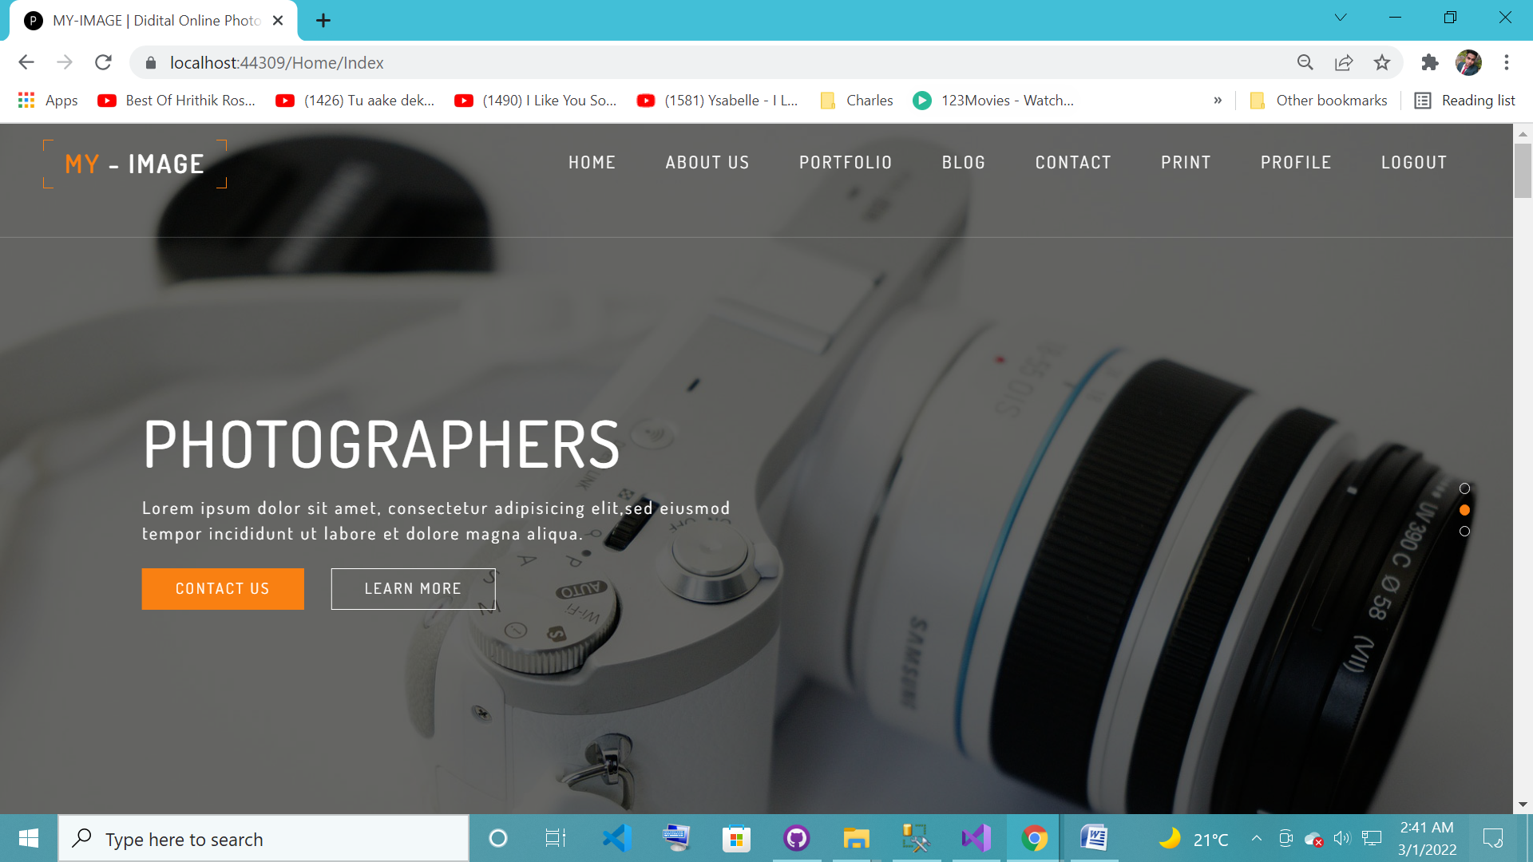

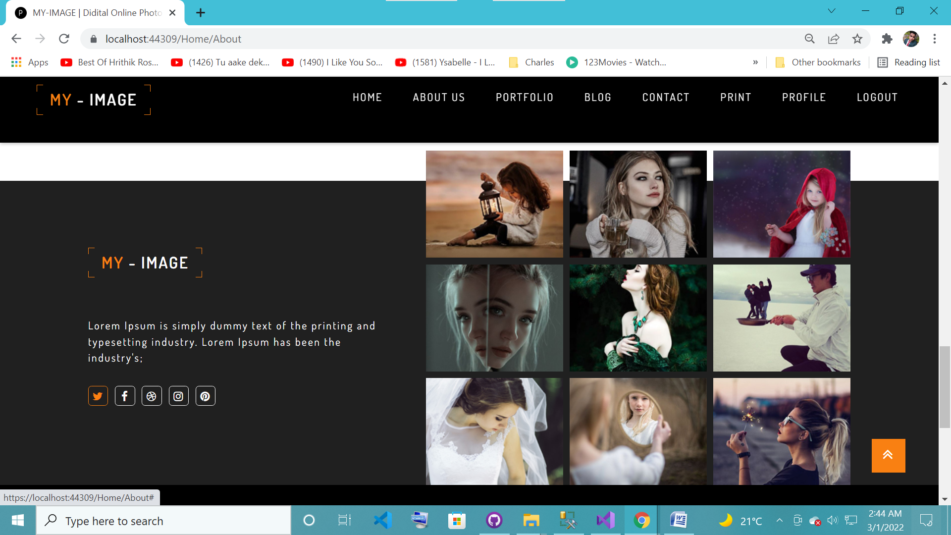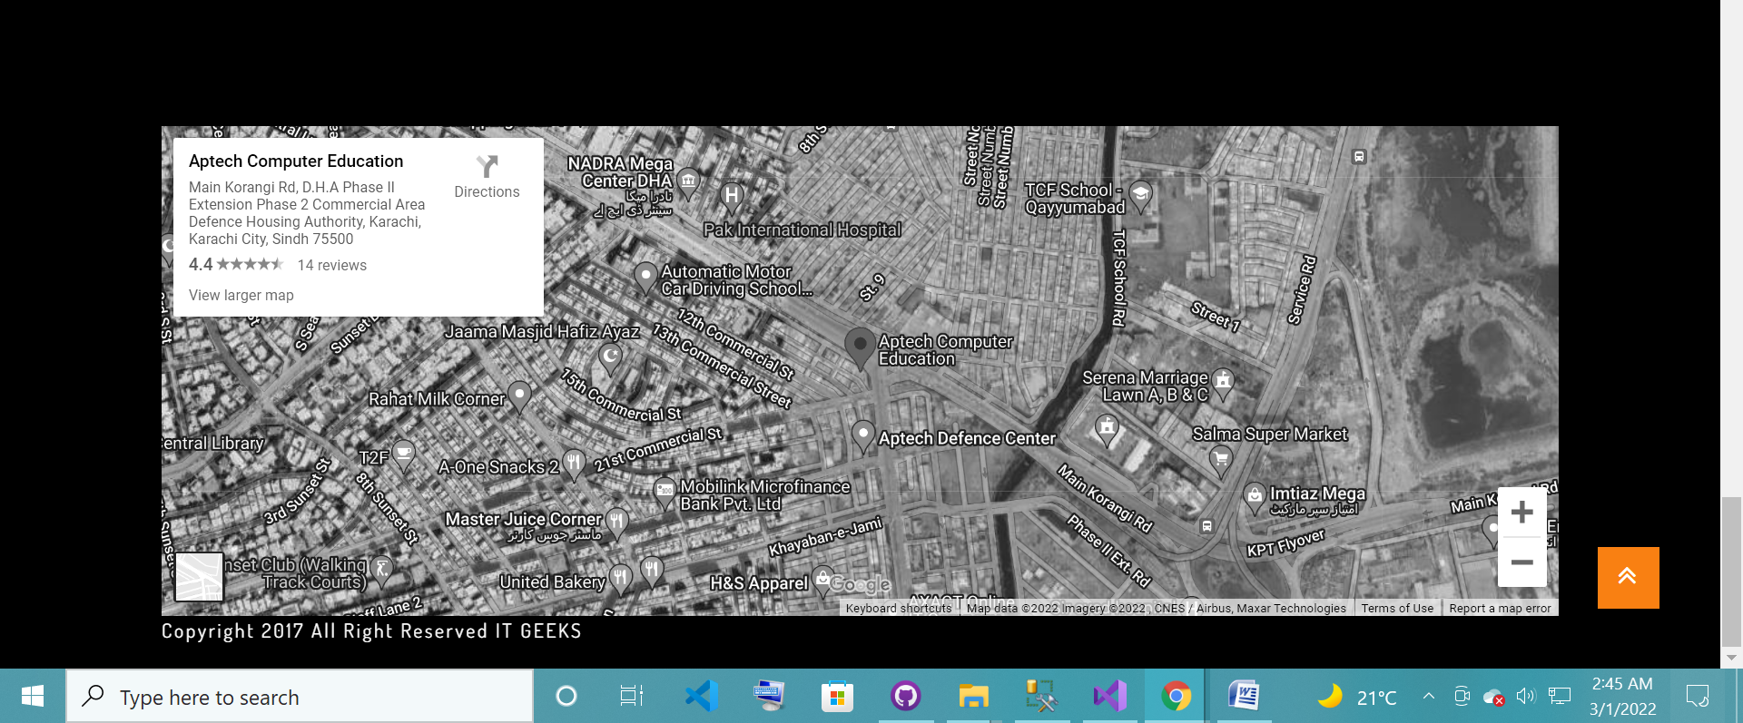

**About:-**

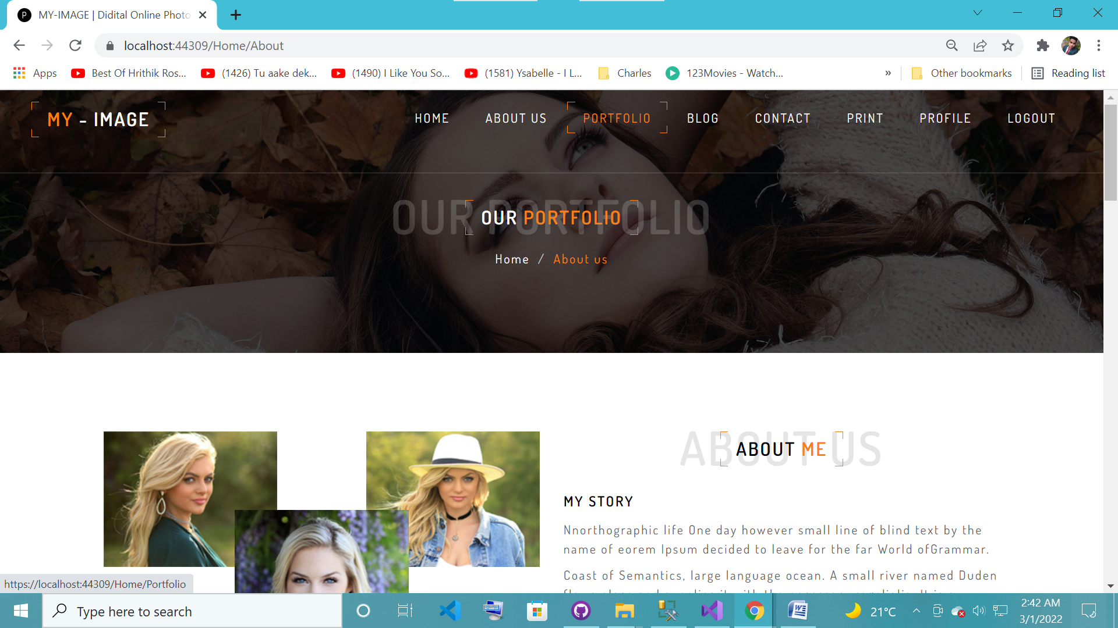

**Login:-**

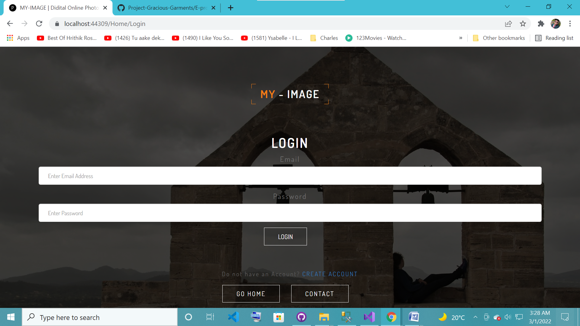

**Registration:**

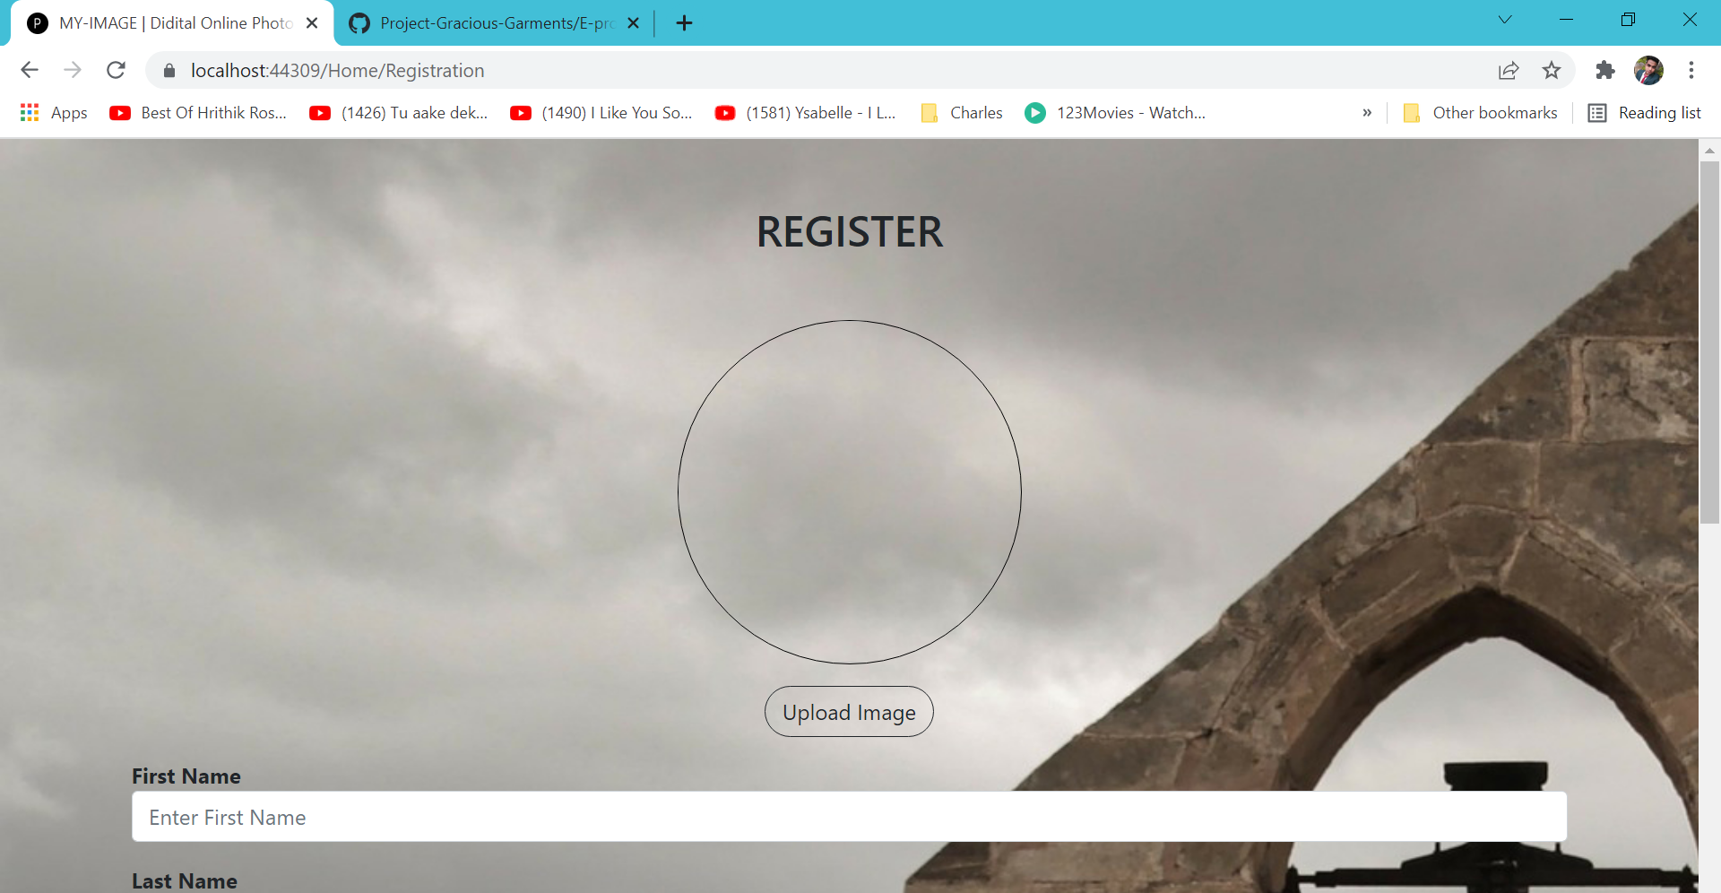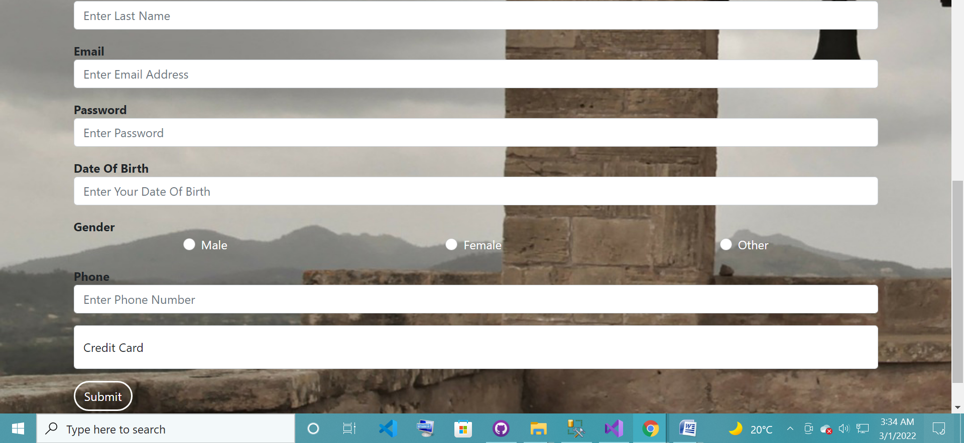

**Portfolio:-**



**Blog:-**



**Contact:-**

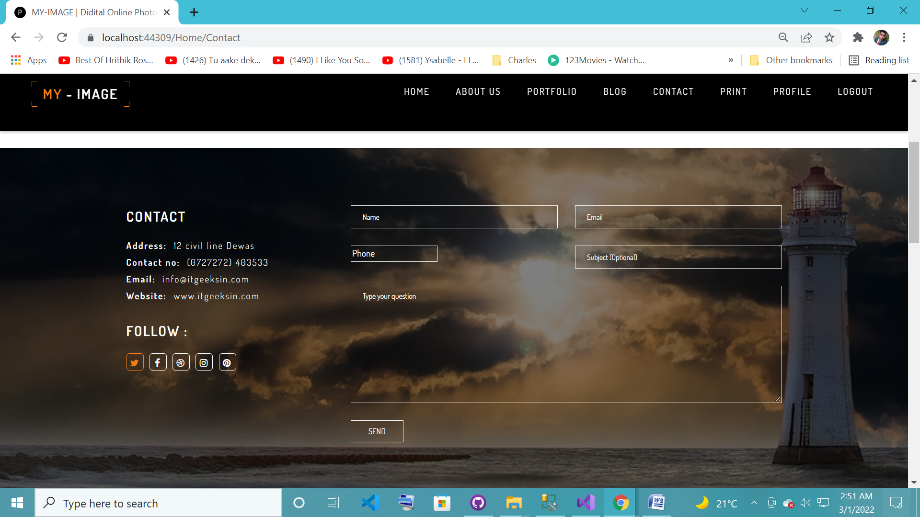

**Order:-**

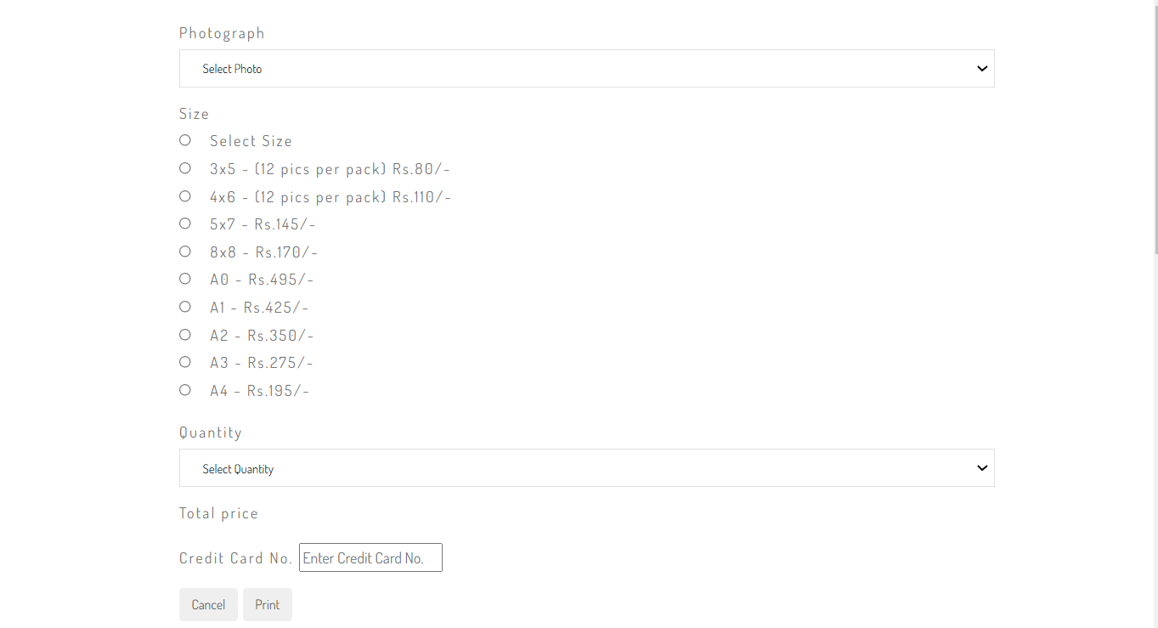

**Profile:-**

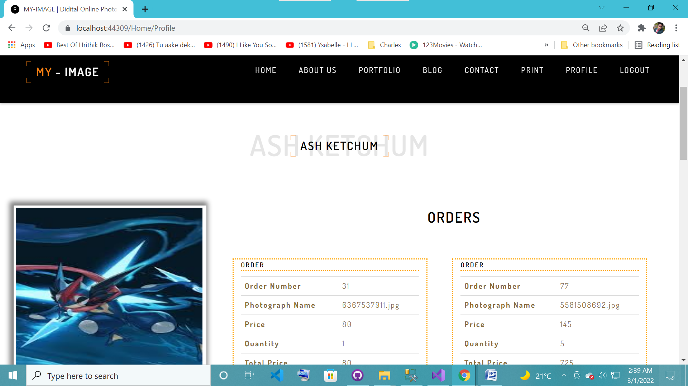

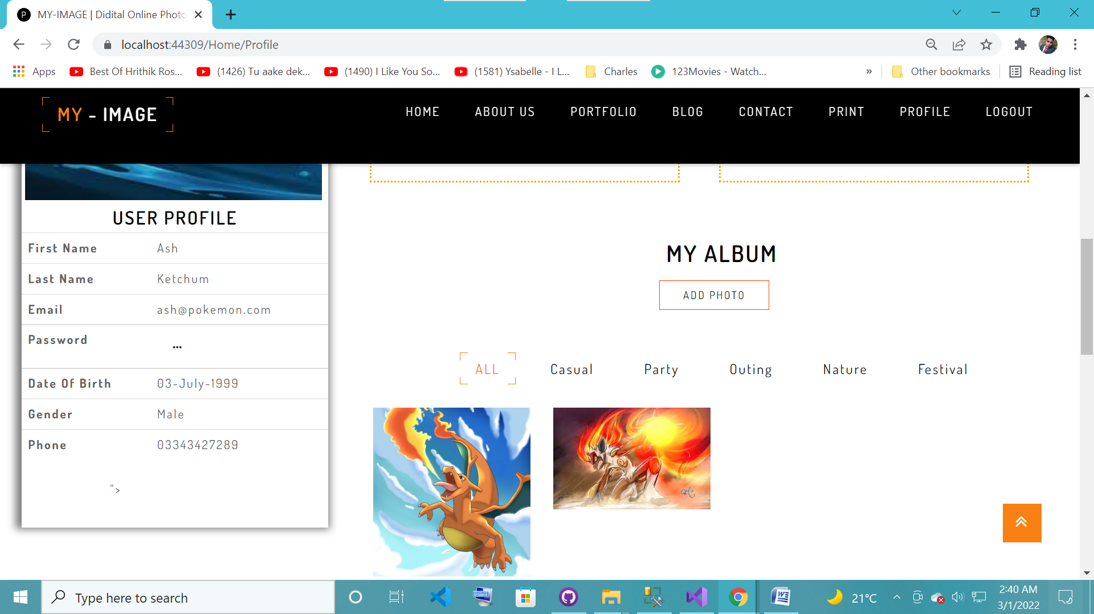

1. Source Code

**Layout:-**

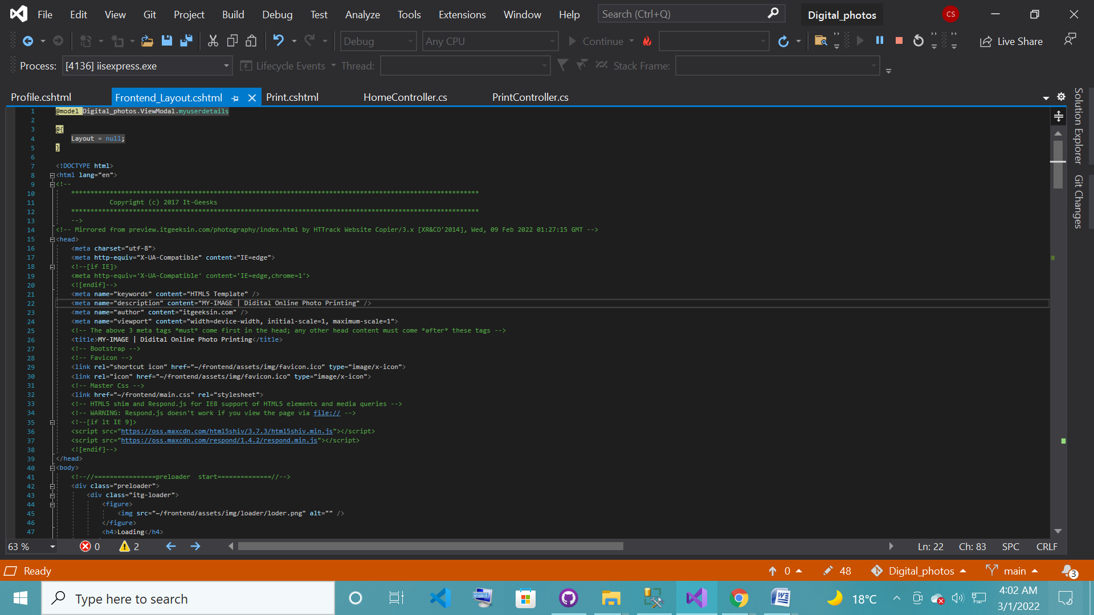

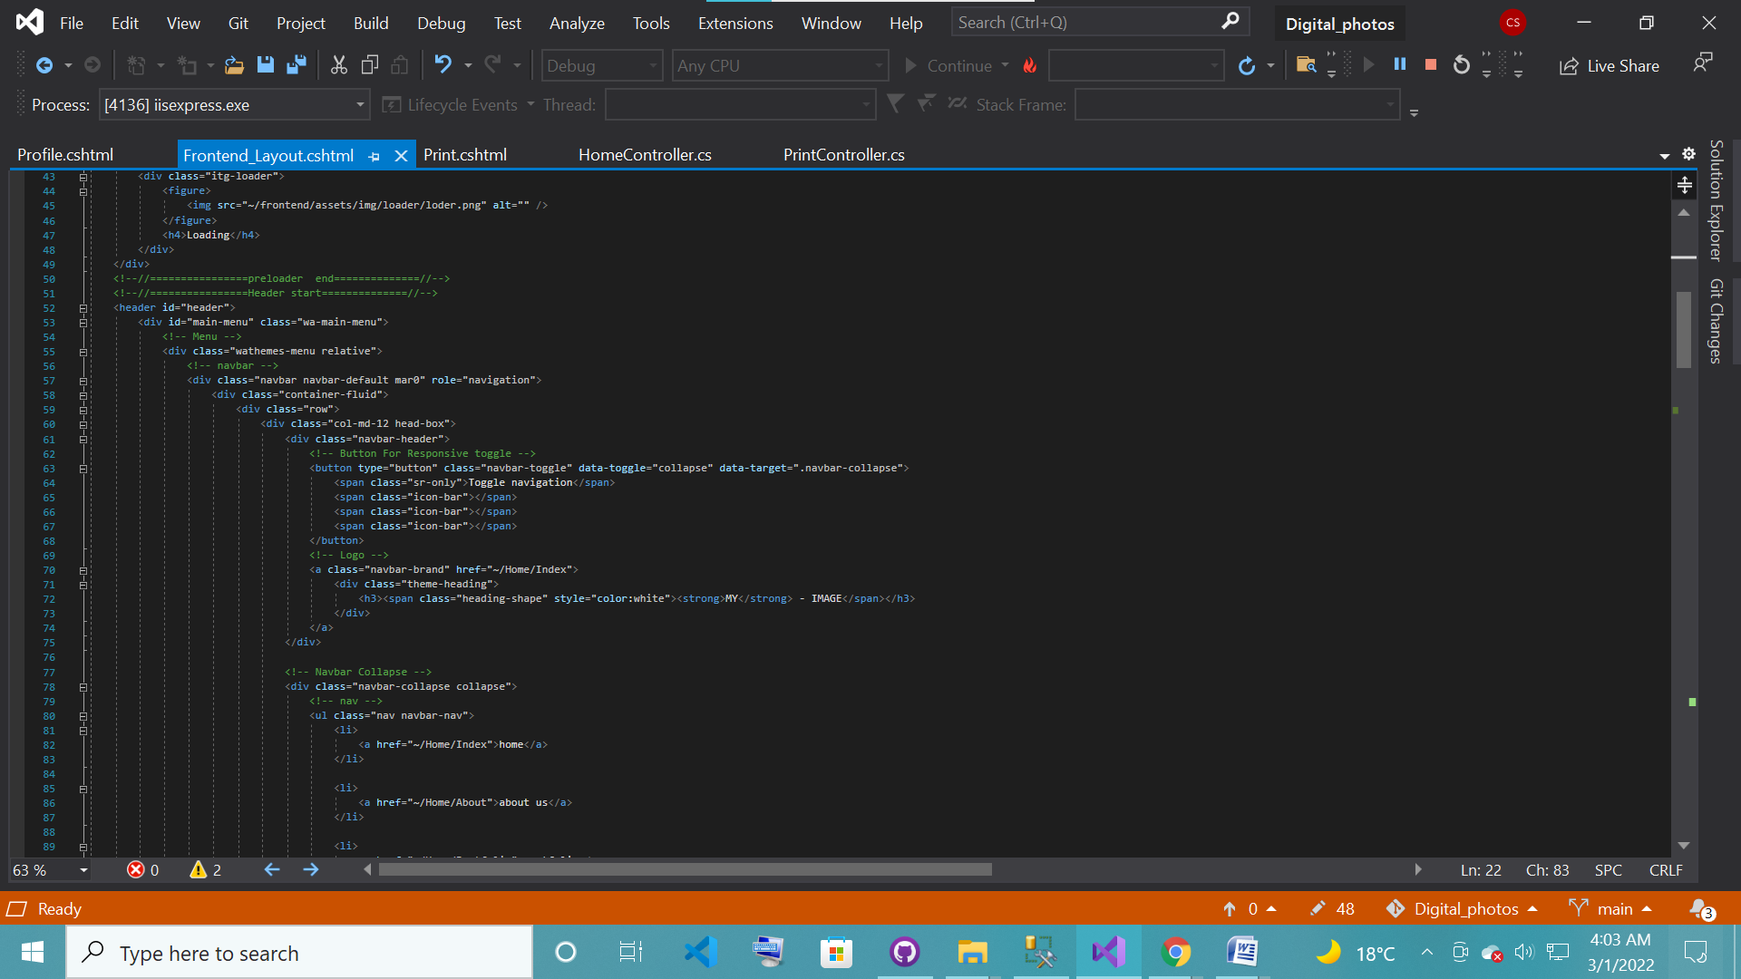

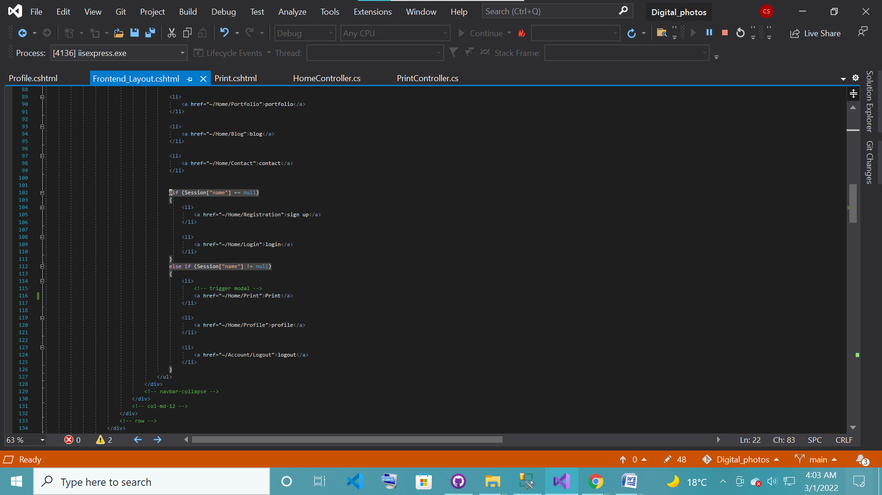

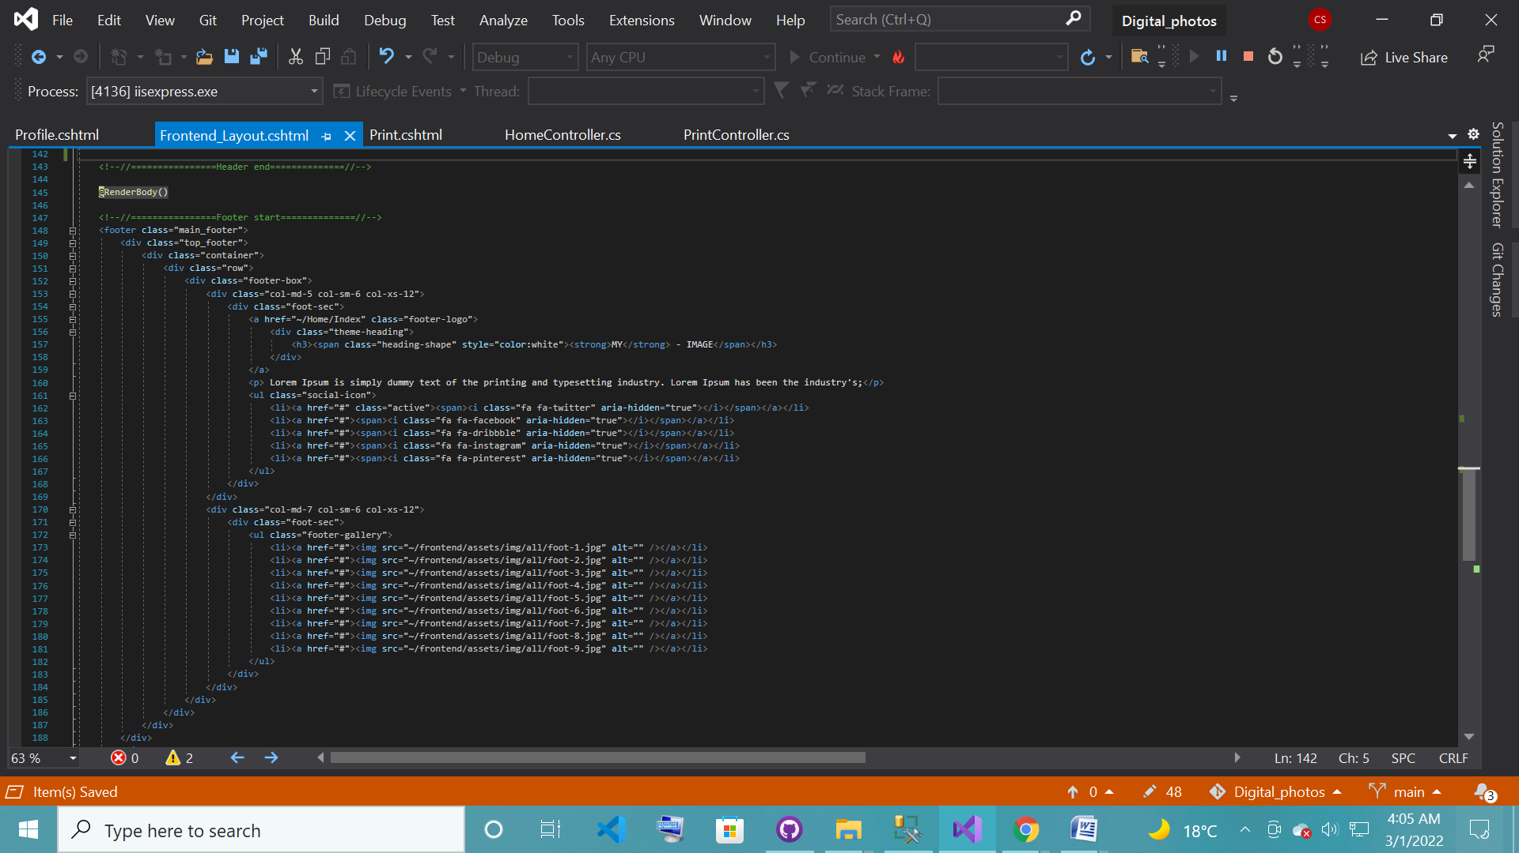

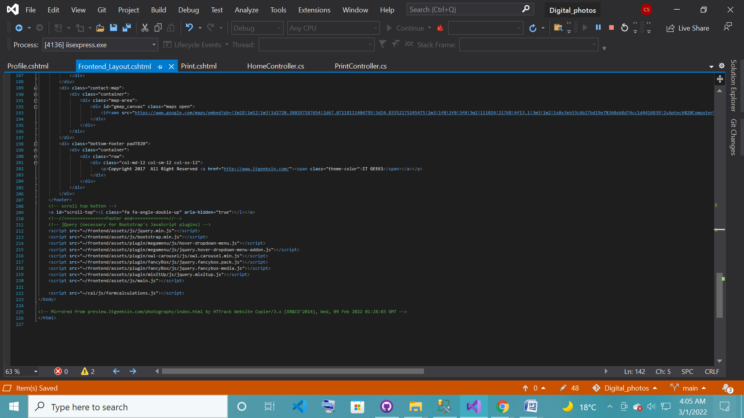

1. User Guide

**Home + Navbar + Footer :-**



We have designed our home page using various sections. Namely: Navbar, Slider, About, Portfolio, Blog, Contact & Footer. Every page regarding our site is present on the Navbar and a location map is given in the footer for contact.



**About:-**



This page contains the information about our website and our work.